

**ConnectED**

A Complete Software Requirements Specification

Version 1.0

**Proponents:**

Reyver Abellanosa

Bryan Alcover

Patricia Monick Herbosana

Anna Mae De Luna

Kenjie Chavez

**RATIONALE**

The ConnectEd Enrollment System is introduced in response to a thorough evaluation of the existing enrollment procedures, which identifies the need for a more advanced and effective approach. The system's implementation is driven by the following important factors:

**1. Efficiency and Accuracy:**

Seeks to completely transform the enrollment process, not only by expediting it for students but also by drastically lowering the possibility of errors, guaranteeing a flawless and error-free procedure.

**2. User-Friendly Interface:**

Acknowledging the broad user base, which includes administrators and students, accessibility is given top priority in the design to facilitate user navigation and interaction.

**3. Centralized Access:**

Acting as a central hub, it consolidates all necessary data and features on a user-friendly Landing Page and a well-organized Dashboard. By facilitating instant access to essential tools and resources, this centralization significantly enhances the user experience.

**4. Timely Communication:**

Guaranteeing timely communication to keep stakeholders informed, this feature fosters an active and involved user community. It plays a crucial role in broadcasting notifications, deadlines, and essential information.

**5. Administrative Oversight:**

This administrative oversight ensures effective control, facilitating informed decision-making and efficient management of the enrollment process.

**6. Effective Communication:**

Creating an accessible and well-organized information repository, it classifies and archives news, events, and announcements, thereby facilitating effective communication.

**7. Support Channels:**

Creating dedicated support channels to prioritize user assistance, this guarantees users dependable and easily accessible avenues for assistance requests by providing direct contact details for pertinent departments or a contact form for general inquiries.

**8. Flexibility and Adaptability:**

Designed to be both flexible and adaptive, the system allows institutions to easily customize it, ensuring simplicity in adapting to their unique and changing needs.

All things considered, the ConnectEd Enrollment System represents a purposeful endeavor to enhance the enrollment process, transcending mere technical improvements. To revolutionize college enrollment management, the system amalgamates adaptability, efficiency, and a user-centric design.

**SYSTEM DESCRIPTION**

**Overall Goal:**

ConnectEd combines efficiency, adaptability, and user-centric design to improve the enrollment process. It represents a deliberate effort to significantly improve college enrollment management, going beyond technical advancements.

It is a monument to creativity and advancement, opening the door for a time when enrollment procedures are not only practical but also customized to improve the quality of education as a whole.

**Features:**

Landing Page

* Welcome message.
* Brief overview of the Enrollment Management System.
* Highlights of key features and benefits.
* Call-to-action buttons for logging in or accessing the system.

**Footer:**

* Quick links to important pages (e.g., Home, Dashboard, News, Contact Us).
* Copyright information.
* Privacy policy and terms of use links.
* Social media links (if applicable).

**Contact Us:**

* Contact form for general inquiries or support.
* Contact information for relevant departments (e.g., admissions, support services).

News Section:

* Latest announcements, news, and events.
* Categorized sections for easy navigation (e.g., Announcements, News, Events).
* Archive for past news and announcements.

**Dashboard:**

Sidebar:

Dashboard: Overview of personalized information, announcements, and tasks.

Post:

* Announcement: Add new announcement.
* News: Add new news.
* Events: Add new events.

Enroll: Access enrollment form.

Students: View list of students.

**Administrator:**

* User: Add new user.
* User Types: Add more user types.
* User Activity Logs: View user activities.

Settings: Change password.

Log Out: Securely log out.

**Main Content:**

* Dynamic content based on the selected sidebar option.
* Quick access to relevant actions and information.
* Real-time updates and notifications.

This structure aims to provide a user-friendly interface with easy navigation, ensuring that users can access the information and functionalities they need efficiently. The sidebar layout in the dashboard offers quick access to key sections, and the news section keeps users informed about important updates. Adjustments can be made based on the specific needs and preferences of your EMS users.

**ERD**

**Use Case Diagram**

**APIs**

API description:

Method: GET

Headers: {Authorization: adminTokenJWT}

URL: http://localhost:4000/api/v1/announcements

Sample Response (Success):

{

"status": 200,

"data": [

{

"announcement_id": 1,

"announcement_title": "asdasd",

"announcement_description": "aasdsadsadsadsad",

"user_id": 5,

"created_at": "2023-12-17T02:04:03.000Z"

},

{

"announcement_id": 2,

"announcement_title": "Announcements",

"announcement_description": "LOrem LOrem LOrem LOrem LOrem LOrem LOrem LOrem LOrem LOrem LOrem LOrem LOrem LOrem LOrem LOrem LOrem LOrem LOrem LOrem ",

"user_id": 2,

"created_at": "2023-12-17T07:33:17.000Z"

}

]

}

API description:

Method: GET

Headers: {Authorization: adminTokenJWT}

URL: http://localhost:4000/api/v1/events

Sample Response (Success):

{

"status": 200,

"data": [

{

"event_id": 1,

"event_title": "sadsadsad",

"event_description": "Naibog ko niya",

"user_id": 5,

"event_date": "2023-12-19T16:00:00.000Z",

"created_at": "2023-12-17T02:05:03.000Z"

}

]

}

API description:

Method: GET

Headers: {Authorization: adminTokenJWT}

URL: http://localhost:4000/api/v1/news

Sample Response (Success):

{

"status": 200,

"data": [

{

"news_id": 1,

"news_title": "news",

"news_description": "laksdjlsakdjlaksdjlksadjaslkdjsaldjalsdsad",

"user_id": 5,

"created_at": "2023-12-17T02:05:52.000Z"

}

]

}

API description:

Method: GET

Headers: {Authorization: adminTokenJWT}

URL: http://localhost:4000/api/v1/users

Sample Response (Success):

{

"status": 200,

"data": [

{

"user_id": 1,

"username": "reyverako",

"email": "reyverako@email.com",

"created_at": "2023-12-16T12:23:41.000Z"

},

{

"user_id": 4,

"username": "fufu",

"email": "haha@gmail.com",

"created_at": "2023-12-16T14:21:49.000Z"

},

{

"user_id": 5,

"username": "admin",

"email": "admin@gmail.com",

"created_at": "2023-12-16T14:38:55.000Z"

},

{

"user_id": 6,

"username": "jhonryl123",

"email": "jhonryl@gmail.com",

"created_at": "2023-12-16T15:40:36.000Z"

},

{

"user_id": 7,

"username": "cyrilbayot",

"email": "cyril@gmail.com",

"created_at": "2023-12-17T02:41:29.000Z"

},

{

"user_id": 8,

"username": "bryanbayot",

"email": "bryan@gmail.com",

"created_at": "2023-12-17T02:53:15.000Z"

},

{

"user_id": 9,

"username": "tsobanesthemaster",

"email": "22104668@usc.edu.ph",

"created_at": "2023-12-17T06:39:37.000Z"

},

{

"user_id": 10,

"username": "bryanskie",

"email": "bryanskie@gmail.com",

"created_at": "2023-12-17T06:48:19.000Z"

},

{

"user_id": 11,

"username": "annamaegwapa",

"email": "anna@gmail.com",

"created_at": "2023-12-17T07:26:32.000Z"

},

{

"user_id": 12,

"username": "huhuhuhu",

"email": "huhu@gmail.com",

"created_at": "2023-12-17T07:44:39.000Z"

},

{

"user_id": 13,

"username": "kenjigwapa",

"email": "kenji@gmail.com",

"created_at": "2023-12-17T08:44:19.000Z"

},

{

"user_id": 14,

"username": "bagongaccount",

"email": "aljdslakj@gmail.com",

"created_at": "2023-12-17T08:57:53.000Z"

},

{

"user_id": 15,

"username": "testuser",

"email": "testusergmail.com",

"created_at": "2023-12-17T09:09:29.000Z"

}

]

}

API description:

Method: GET

Headers: {Authorization: adminTokenJWT}

URL: http://localhost:4000/api/v1/students

Sample Response (Success):

{

"status": 200,

"data": [

{

"student_id": 1,

"user_id": 1,

"is_setup": 0,

"status": "enrolled"

},

{

"student_id": 2,

"user_id": 4,

"is_setup": 0,

"status": "enrolled"

},

{

"student_id": 3,

"user_id": 7,

"is_setup": 0,

"status": "enrolled"

},

{

"student_id": 5,

"user_id": 9,

"is_setup": 0,

"status": "enrolled"

},

{

"student_id": 6,

"user_id": 10,

"is_setup": 0,

"status": "enrolled"

},

{

"student_id": 7,

"user_id": 11,

"is_setup": 0,

"status": "enrolled"

},

{

"student_id": 8,

"user_id": 12,

"is_setup": 0,

"status": "enrolled"

},

{

"student_id": 9,

"user_id": 13,

"is_setup": 0,

"status": "enrolled"

},

{

"student_id": 10,

"user_id": 15,

"is_setup": 0,

"status": "enrolled"

}

]

}

API description:

Method: GET

Headers: {Authorization: adminTokenJWT}

URL: http://localhost:4000/api/v1/student_contact_info

Sample Response (Success):

{

"status": 200,

"data": [

{

"student_personal_id": 1,

"user_id": 1,

"student_type": "freshmen",

"course": "BACHELOR OF SCIENCE IN INFORMATION TECHNOLOGY",

"lrn": "119964090002",

"sex": "male",

"last_name": "Abellanosa",

"first_name": "Reyver ",

"middle_name": "Pascual",

"date_of_birth": "2003-09-16T16:00:00.000Z",

"religion": "Christiansd",

"permanent_address": "Zone ",

"postal_code": 6015,

"current_address": "asdasdasdsa",

"civil_status": "single"

},

{

"student_personal_id": 2,

"user_id": 4,

"student_type": "freshmen",

"course": "Bachelor of Science in Computer Science",

"lrn": "119964090005",

"sex": "male",

"last_name": "asdasd",

"first_name": "asdsadsad",

"middle_name": "assdasdsad",

"date_of_birth": "2023-12-20T16:00:00.000Z",

"religion": "asdsadsad",

"permanent_address": "asdsadsad",

"postal_code": 3232,

"current_address": "sadasdsadsa",

"civil_status": "single"

},

{

"student_personal_id": 3,

"user_id": 7,

"student_type": "freshmen",

"course": "Bachelor of Science in Computer Science",

"lrn": "119964090002",

"sex": "male",

"last_name": "Desuyo",

"first_name": "Cyril",

"middle_name": "Manabat",

"date_of_birth": "2023-12-13T16:00:00.000Z",

"religion": "Manggagamot",

"permanent_address": "asdsadasdassad",

"postal_code": 123123,

"current_address": "asdadasd",

"civil_status": "single"

},

{

"student_personal_id": 4,

"user_id": 8,

"student_type": "transferee",

"course": "Bachelor of Science in Computer Science",

"lrn": "1923821938",

"sex": "male",

"last_name": "adasd",

"first_name": "dasdsadsad",

"middle_name": "asdsad",

"date_of_birth": "2023-12-12T16:00:00.000Z",

"religion": "asdasdsadsad",

"permanent_address": "asdasdsad",

"postal_code": 213213,

"current_address": "adsadasdsad",

"civil_status": "single"

},

{

"student_personal_id": 5,

"user_id": 9,

"student_type": "freshmen",

"course": "Bachelor of Science in Computer Science",

"lrn": "asdasdsad",

"sex": "male",

"last_name": "sadsad",

"first_name": "asdasdsad",

"middle_name": "asdasdsad",

"date_of_birth": "2023-12-20T16:00:00.000Z",

"religion": "asdasdsad",

"permanent_address": "asdasdsad",

"postal_code": 23423,

"current_address": "asdasdsad",

"civil_status": "single"

},

{

"student_personal_id": 6,

"user_id": 10,

"student_type": "freshmen",

"course": "Bachelor of Science in Civil Engineering",

"lrn": "119964123123",

"sex": "male",

"last_name": "Alcover",

"first_name": "Bryan ",

"middle_name": "Cadavis",

"date_of_birth": "2004-04-06T16:00:00.000Z",

"religion": "Roman Catholic",

"permanent_address": "Talamban",

"postal_code": 6033,

"current_address": "Talamban",

"civil_status": "single"

},

{

"student_personal_id": 7,

"user_id": 11,

"student_type": "freshmen",

"course": "Bachelor of Science in Physics",

"lrn": "11921322323",

"sex": "female",

"last_name": "De Luna",

"first_name": "Anna Mae",

"middle_name": "Mae",

"date_of_birth": "2003-06-25T16:00:00.000Z",

"religion": "Santos",

"permanent_address": "New Era",

"postal_code": 6034,

"current_address": "New Era",

"civil_status": "married"

},

{

"student_personal_id": 8,

"user_id": 12,

"student_type": "freshmen",

"course": "Bachelor of Arts in History",

"lrn": "123123213",

"sex": "male",

"last_name": "asdasd",

"first_name": "asdasdasda",

"middle_name": "dasdsad",

"date_of_birth": "2023-11-28T16:00:00.000Z",

"religion": "asdasdasd",

"permanent_address": "asdasdasdasd",

"postal_code": 2343,

"current_address": "sadsadsaasdsad",

"civil_status": "single"

},

{

"student_personal_id": 9,

"user_id": 13,

"student_type": "freshmen",

"course": "Bachelor of Science in Civil Engineering",

"lrn": "19129321938",

"sex": "male",

"last_name": "Chaves",

"first_name": "Kenji",

"middle_name": "Tao",

"date_of_birth": "2020-06-16T16:00:00.000Z",

"religion": "Abu sayap",

"permanent_address": "Biringan City",

"postal_code": 404,

"current_address": "Mars",

"civil_status": ""

},

{

"student_personal_id": 10,

"user_id": 15,

"student_type": "freshmen",

"course": "Bachelor of Arts in Psychology",

"lrn": "119237232322",

"sex": "male",

"last_name": "Alcov",

"first_name": "Bryan",

"middle_name": "Cadavix",

"date_of_birth": "2023-12-12T16:00:00.000Z",

"religion": "Catholic",

"permanent_address": "New Era Talamban",

"postal_code": 6000,

"current_address": "New Era Talamban",

"civil_status": ""

}

]

}

API description:

Method: GET

Headers: {Authorization: adminTokenJWT}

URL: http://localhost:4000/api/v1/courses

Sample Response (Success):

{

"status": 200,

"data": [

{

"course_id": 1,

"course_name": "Bachelor of Science in Computer Science",

"slots": 50

},

{

"course_id": 2,

"course_name": "Bachelor of Arts in English Literature",

"slots": 40

},

{

"course_id": 3,

"course_name": "Bachelor of Business Administration",

"slots": 60

},

{

"course_id": 4,

"course_name": "Bachelor of Science in Electrical Engineering",

"slots": 45

},

{

"course_id": 5,

"course_name": "Bachelor of Science in Nursing",

"slots": 55

},

{

"course_id": 6,

"course_name": "Bachelor of Arts in Psychology",

"slots": 35

},

{

"course_id": 7,

"course_name": "Bachelor of Science in Mechanical Engineering",

"slots": 40

},

{

"course_id": 8,

"course_name": "Bachelor of Science in Environmental Science",

"slots": 30

},

{

"course_id": 9,

"course_name": "Bachelor of Fine Arts in Graphic Design",

"slots": 25

},

{

"course_id": 10,

"course_name": "Bachelor of Science in Chemistry",

"slots": 30

},

{

"course_id": 11,

"course_name": "Bachelor of Arts in History",

"slots": 40

},

{

"course_id": 12,

"course_name": "Bachelor of Science in Civil Engineering",

"slots": 50

},

{

"course_id": 13,

"course_name": "Bachelor of Science in Mathematics",

"slots": 35

},

{

"course_id": 14,

"course_name": "Bachelor of Arts in Political Science",

"slots": 45

},

{

"course_id": 15,

"course_name": "Bachelor of Business in Marketing",

"slots": 55

},

{

"course_id": 16,

"course_name": "Bachelor of Science in Physics",

"slots": 30

},

{

"course_id": 17,

"course_name": "Bachelor of Arts in Sociology",

"slots": 40

},

{

"course_id": 18,

"course_name": "Bachelor of Science in Biotechnology",

"slots": 25

},

{

"course_id": 19,

"course_name": "Bachelor of Business in Finance",

"slots": 50

},

{

"course_id": 20,

"course_name": "Bachelor of Arts in Communication Studies",

"slots": 35

}

]

}

**SYSTEM MOCK-UP**

**LandingPage /** Home

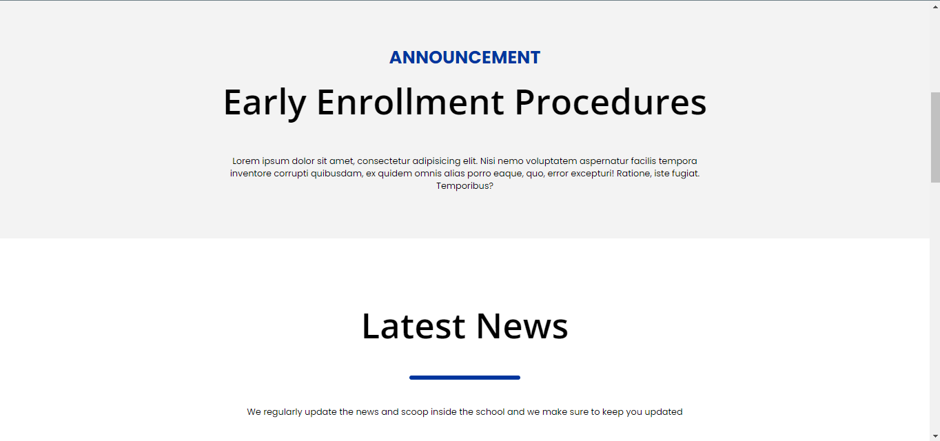

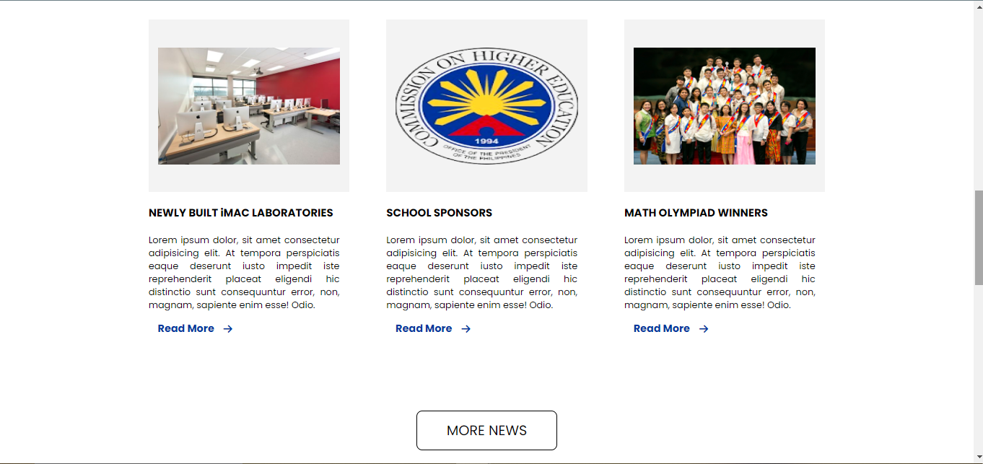

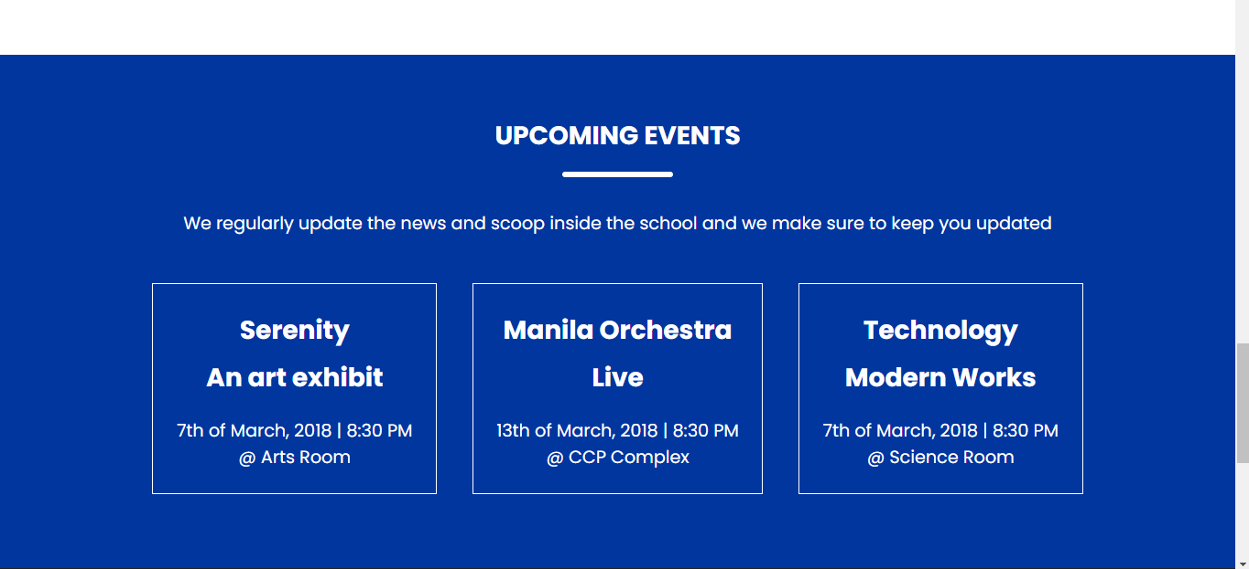

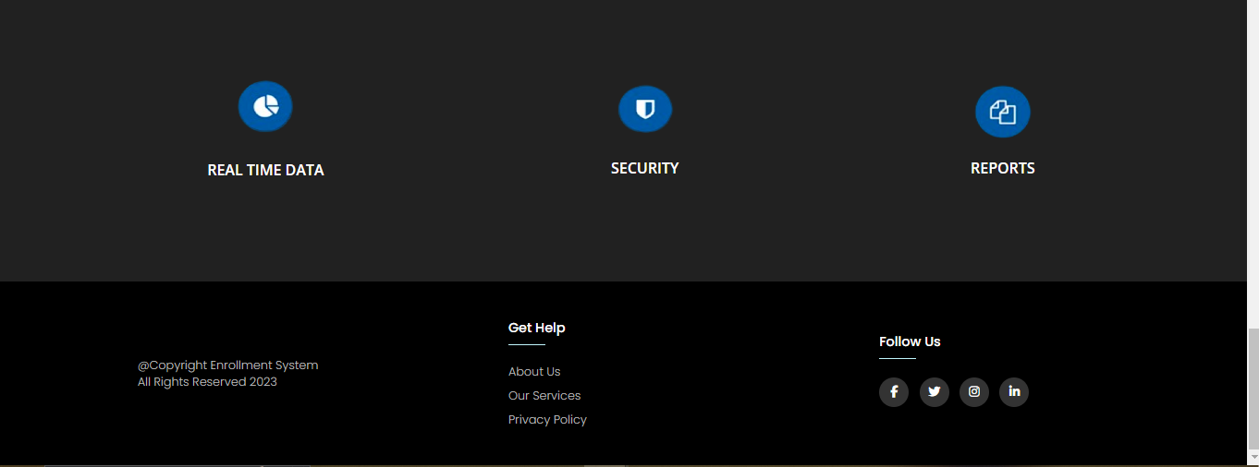

**LandingPage /** News

****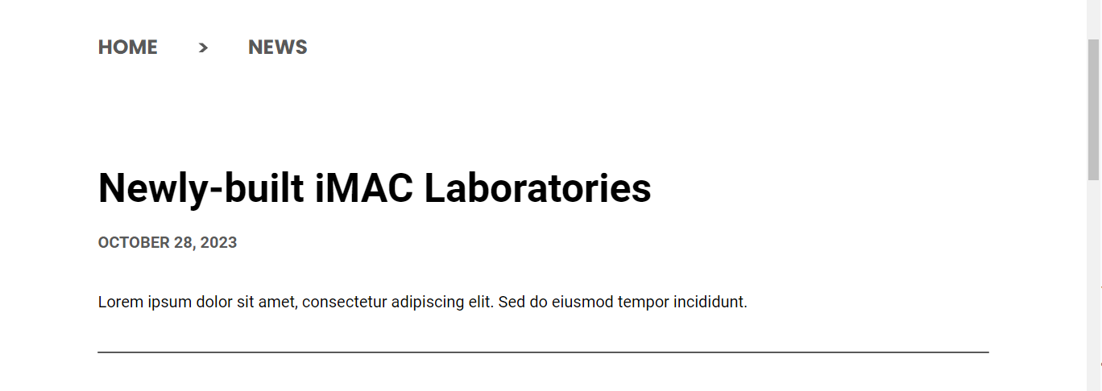

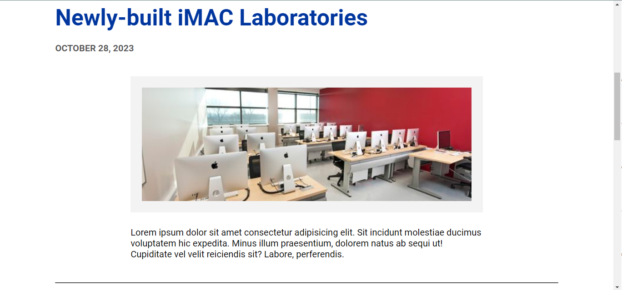

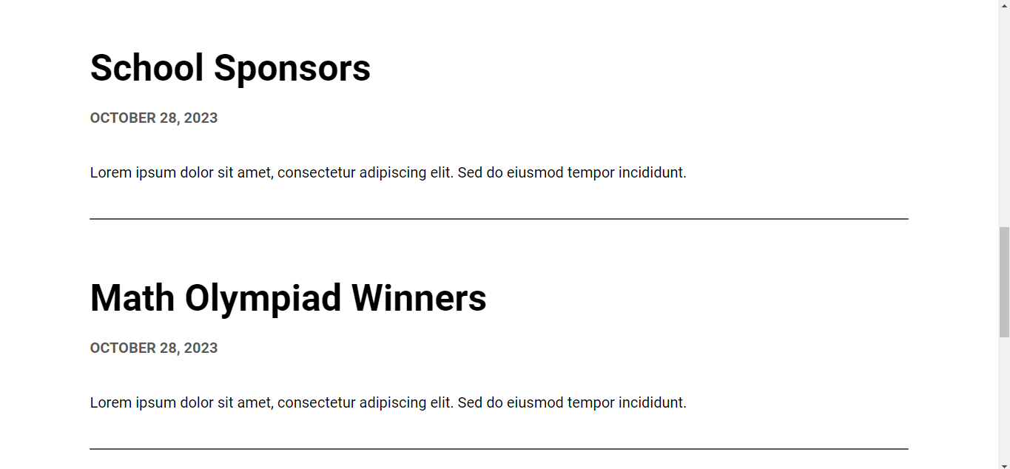

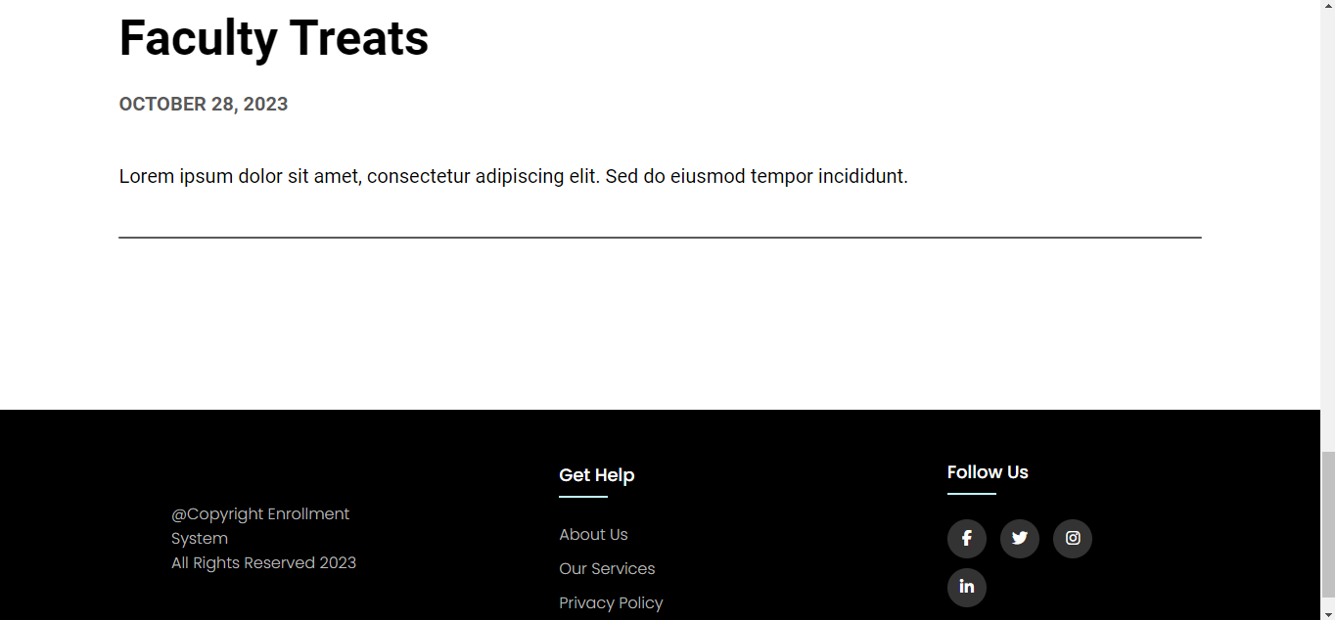

**LandingPage /** Contacts

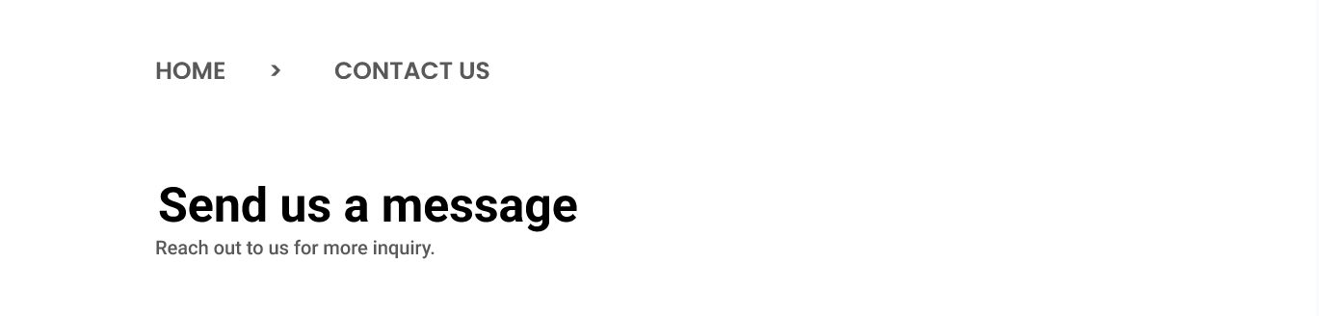

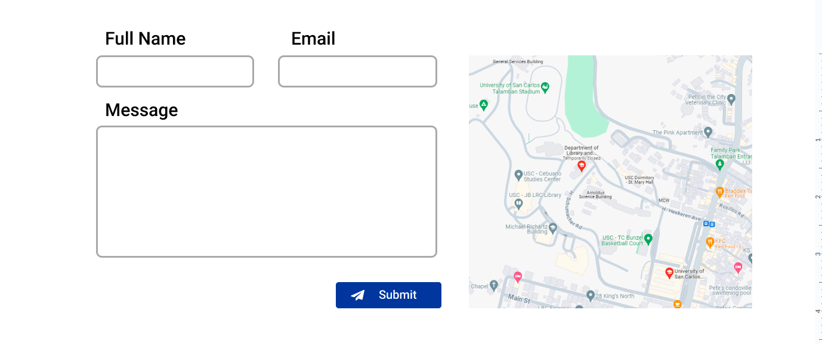

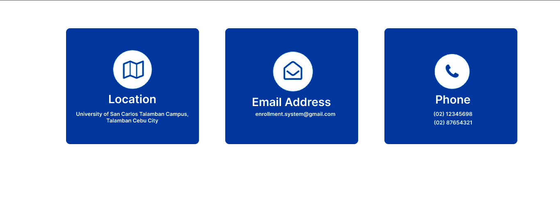

**Login Page**



**Creating Account Page /** Register Form for Enrollment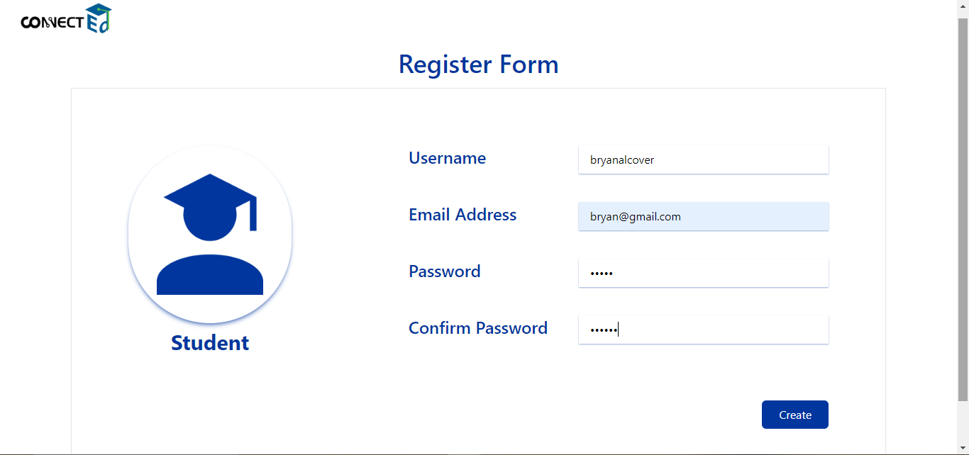

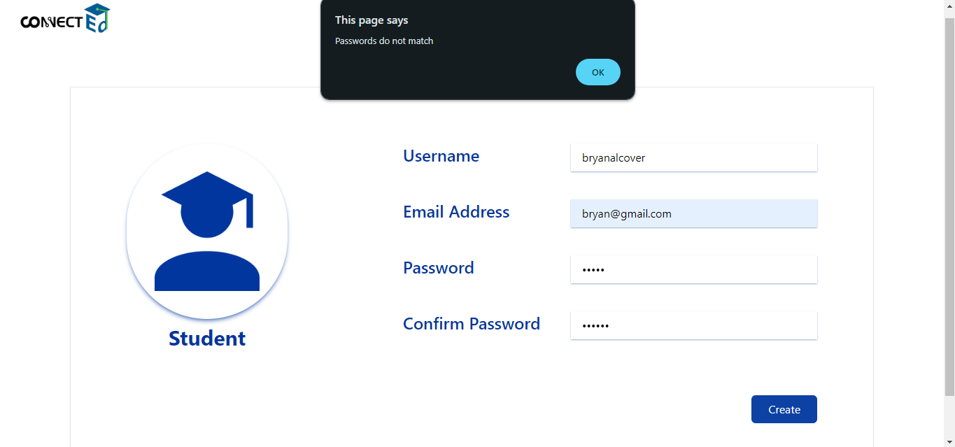

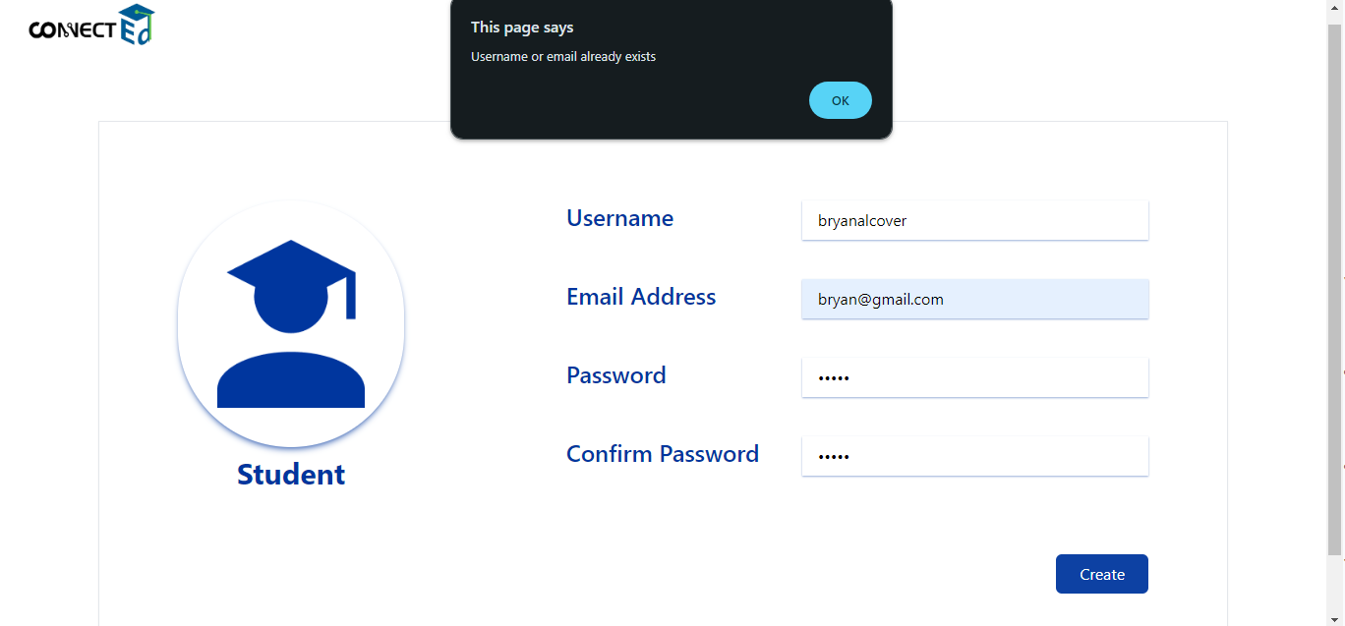

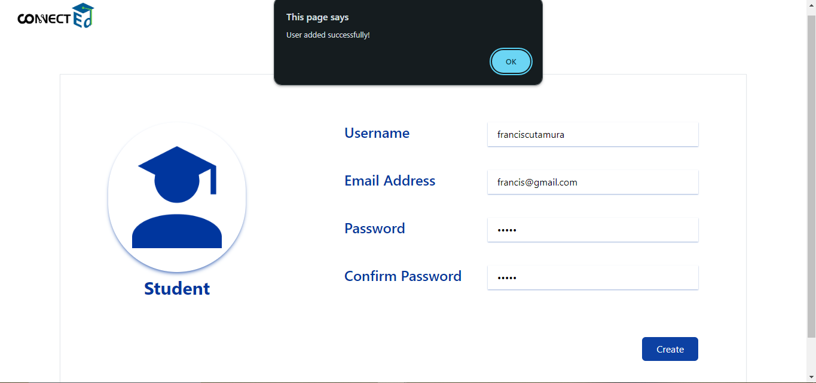

**Login Account /** Student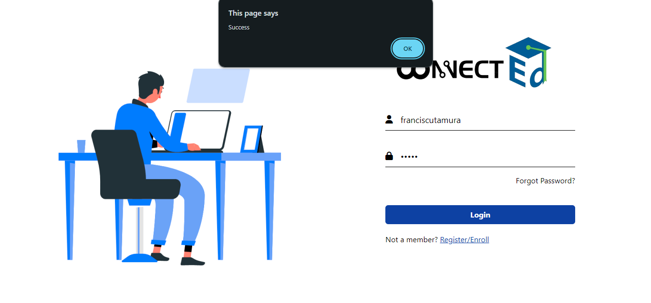

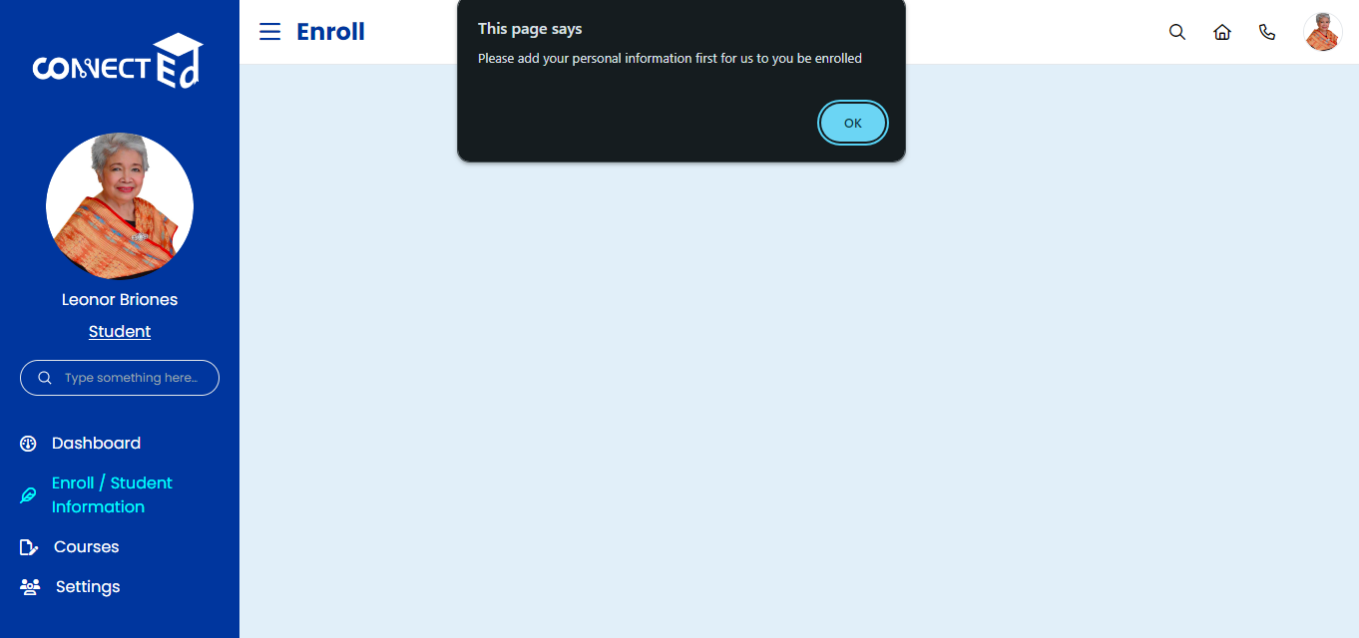

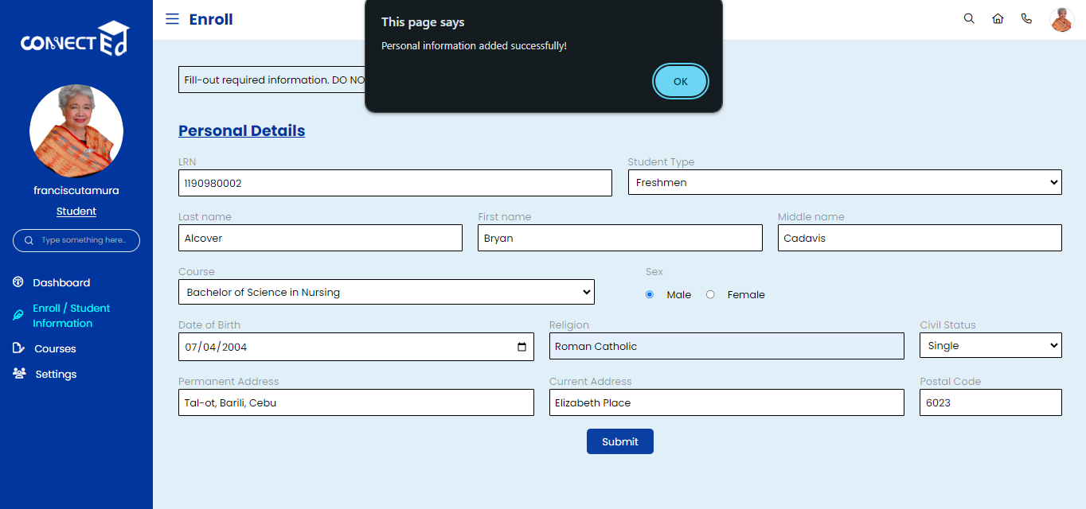

**Student Account /** Pending status for enrollment

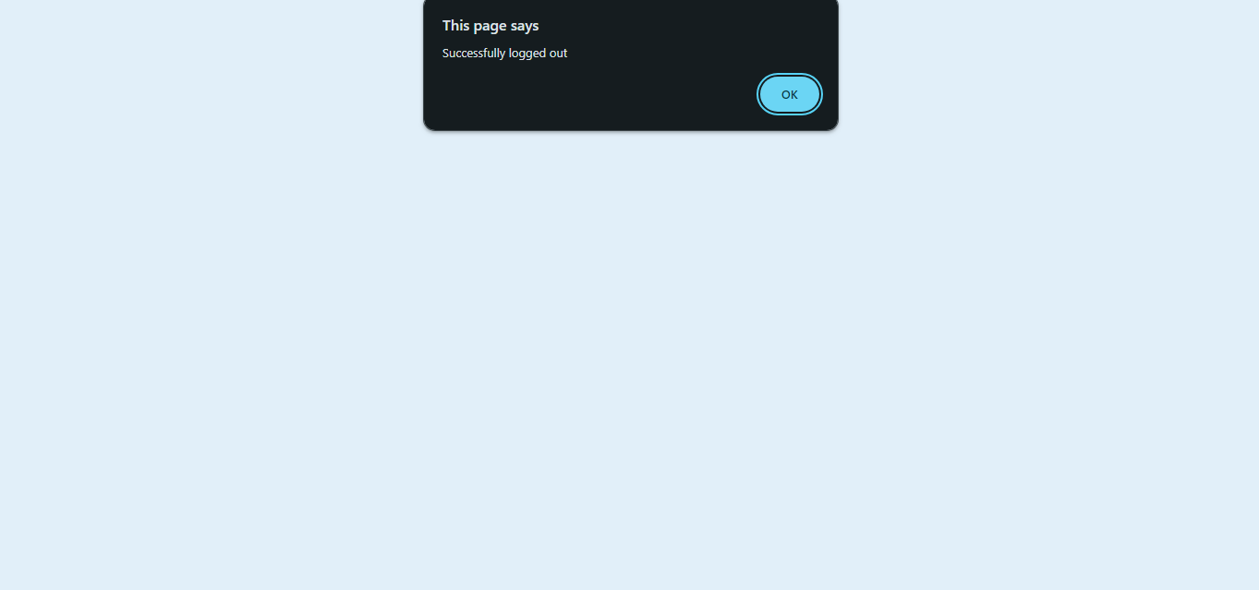

**Login Account /** Admin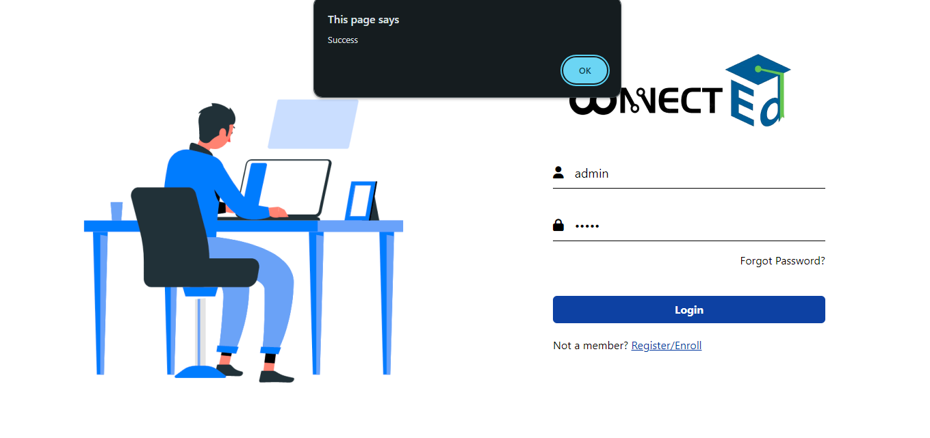

**Admin /** Dashboard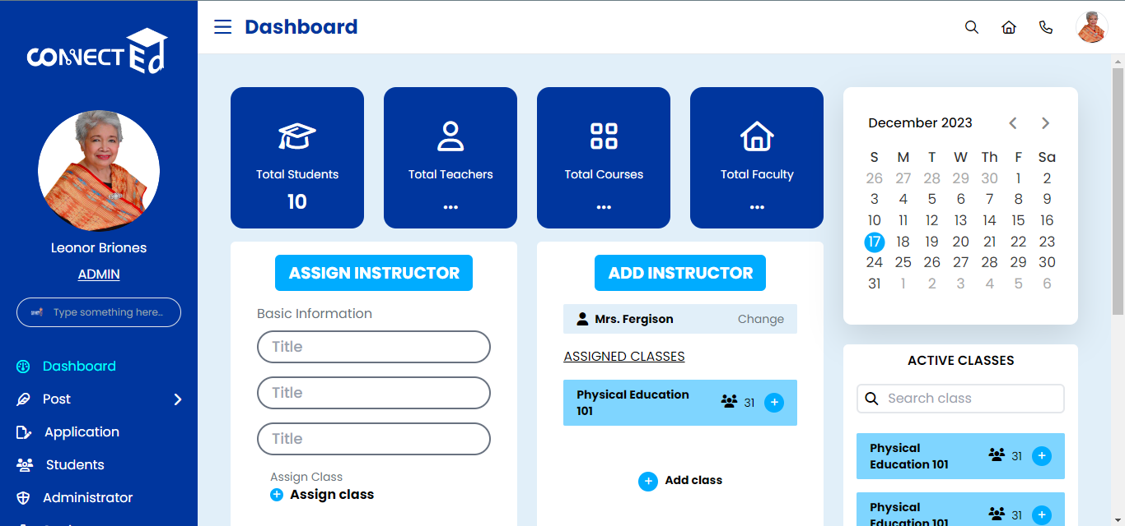

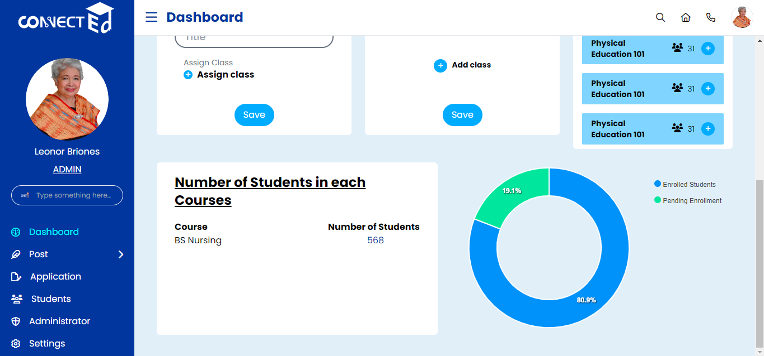

**Admin /** Post

**Announcements**

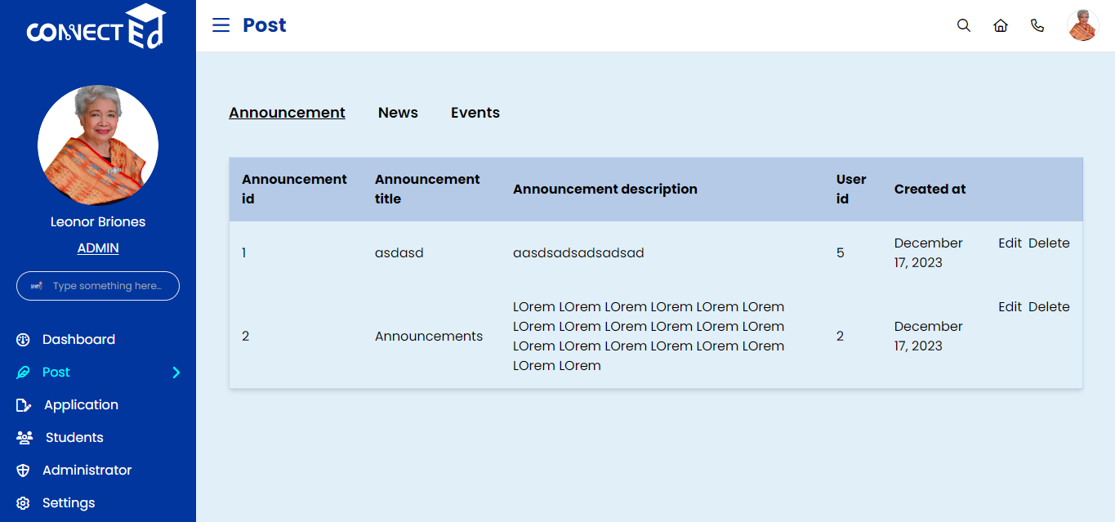

**News**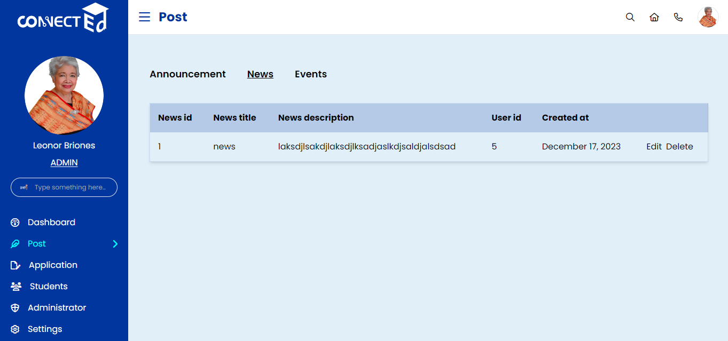

**Events**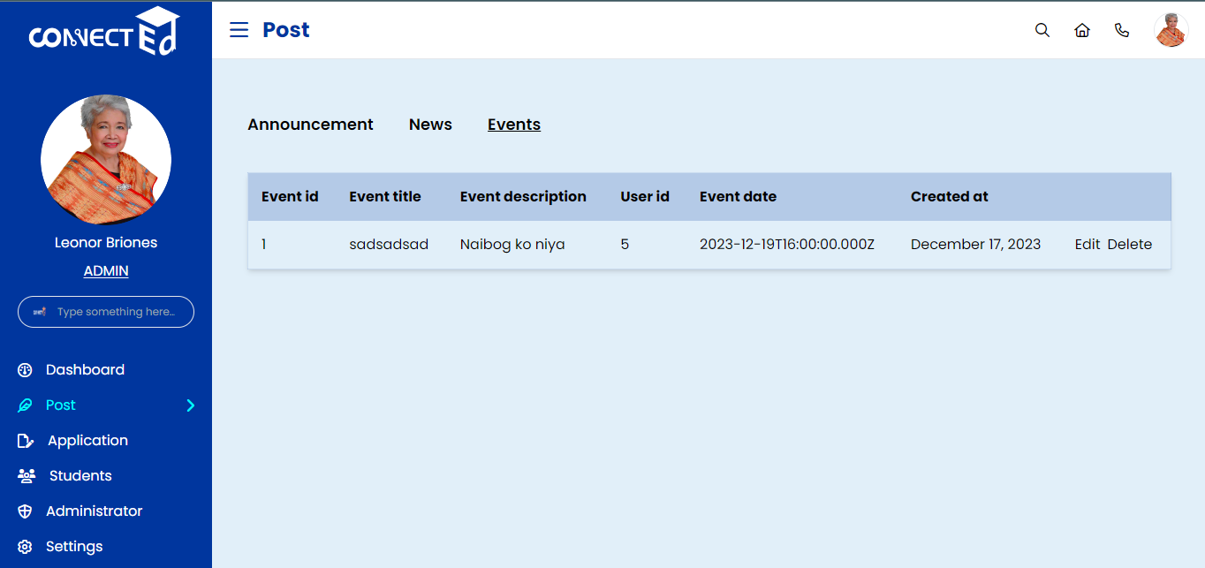

**Admin /** Application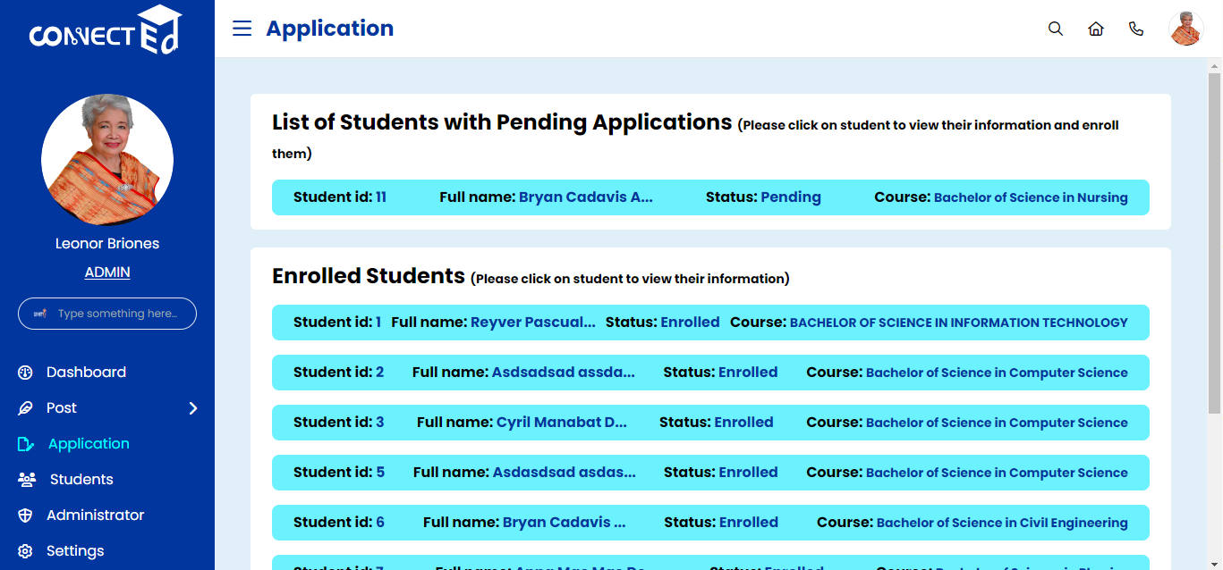

**Admin / Application /** Confirming students' application forms for enrollment

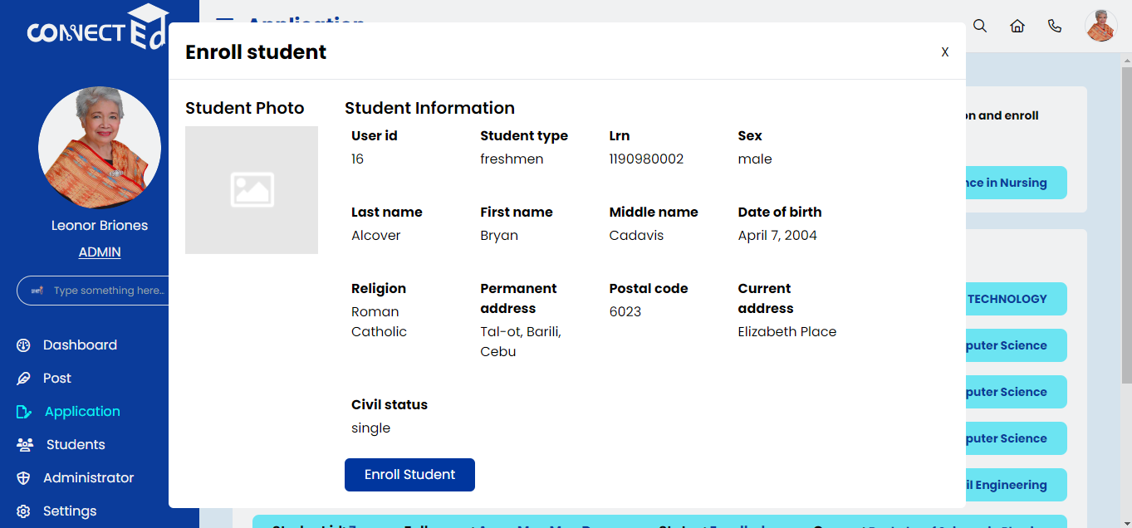

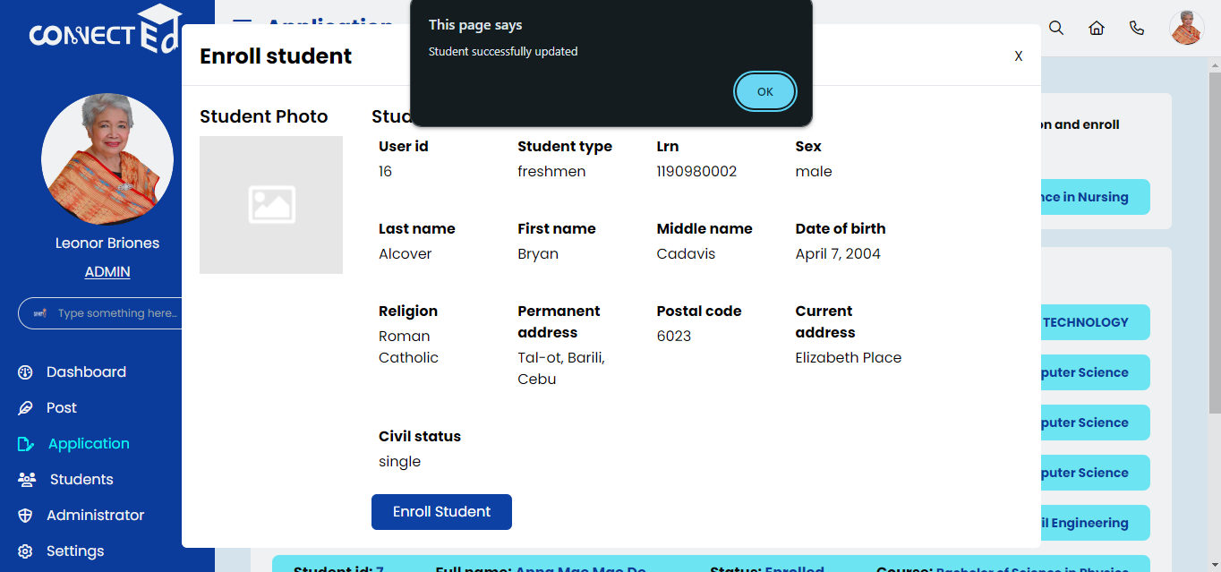

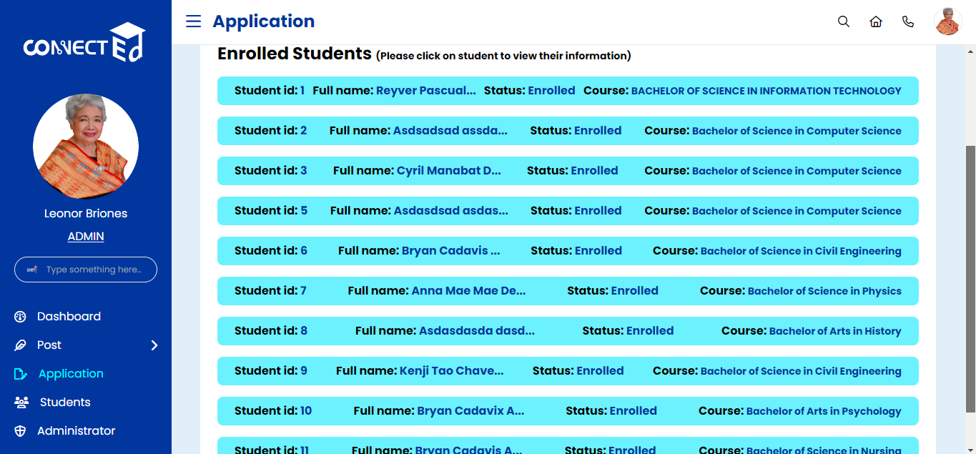

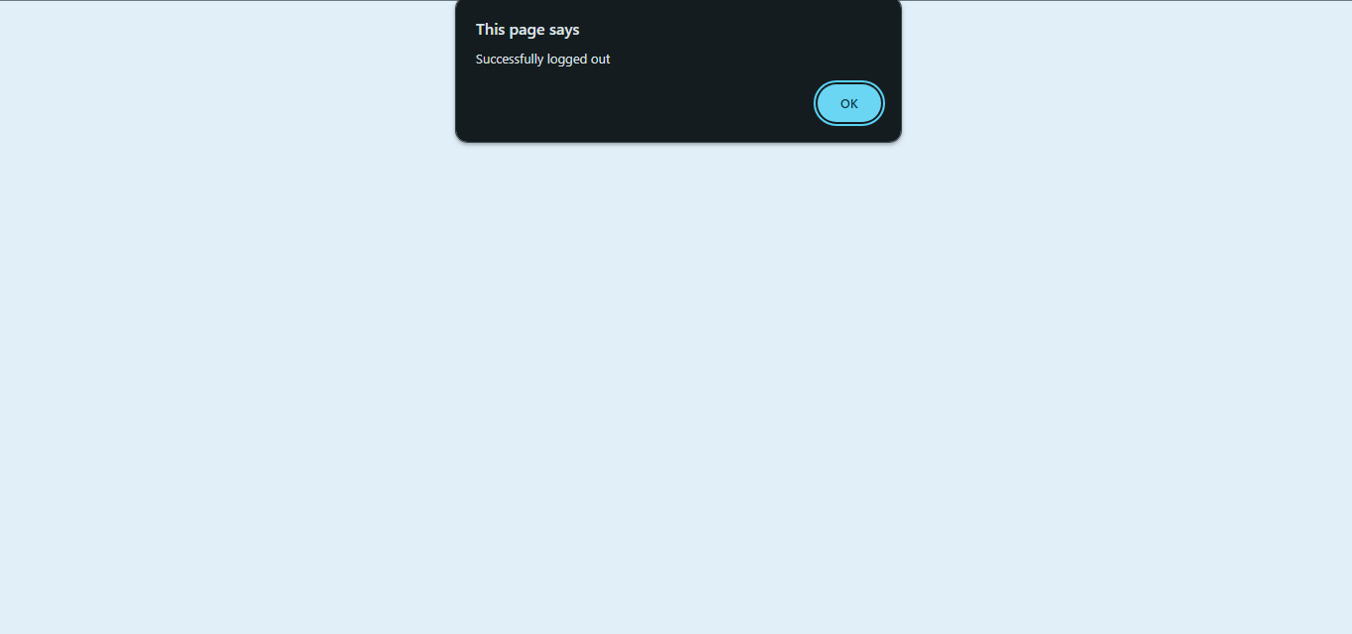

**Student Account /** Enrolled Status

**Dashboard**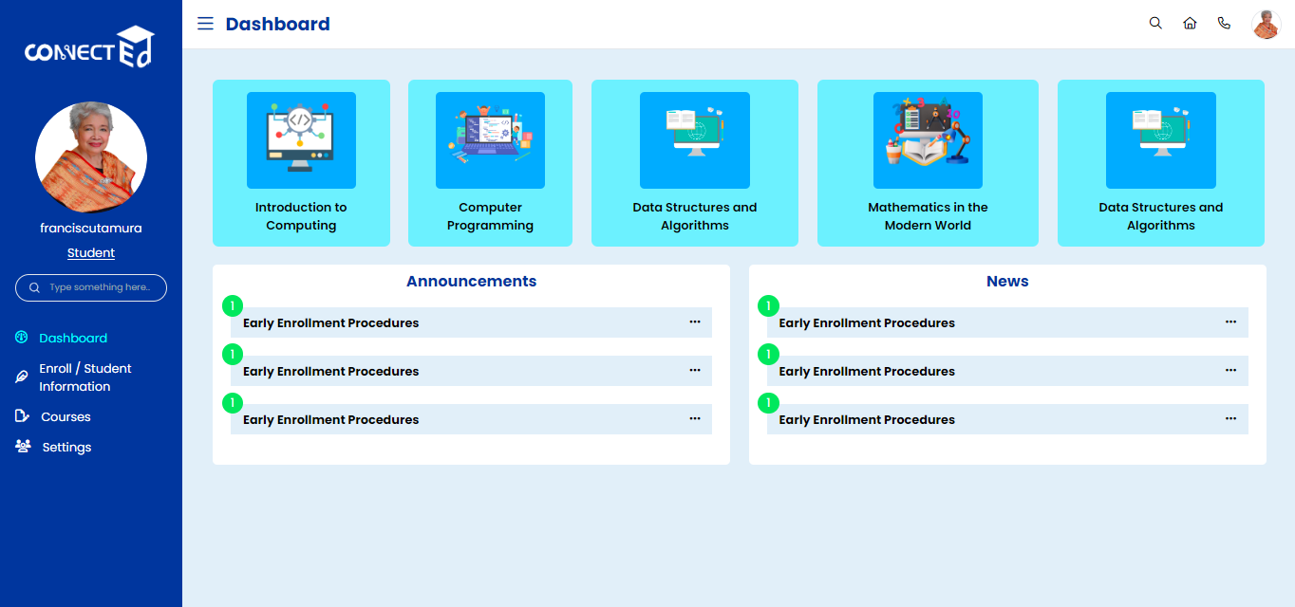

**Enroll / Student Information**